Can the Hyde Park number be defended statistically?
Reference-class comparison, regression on public project costs, and Monte Carlo on the estimate's own cost layers
Methods memo, Cost Estimating Center of Excellence, Eversource Energy, 29 September 2026. Companion to the Hyde Park BESS cost analysis deck, Basis of Estimate and whitepaper. Internal; contains vendor-confidential pricing.

Recommendation
Use three methods together, in this order of weight, and do not let any one of them carry the argument alone. First, a reference class of thirteen utility-owned projects at or below 100 MWh, with Hyde Park placed inside it at each cost boundary. Second, a log-log regression on twenty-six public projects that isolates the size and duration effects and yields a prediction interval for a 20 MWh, two-hour project. Third, a Monte Carlo on the thirteen cost layers of the Rev 3 estimate, which tests whether the risk and contingency carried are consistent with the uncertainty in the elements. The reference class and the regression are statistically viable for bracketing, not for pricing: with n of 13 and 26, an unexplained spread of plus or minus 36 percent, and heterogeneous scope definitions, they answer 'is this number plausible for a project of this size and duration' and nothing finer. The Monte Carlo is the method that a regulator or an internal reviewer can interrogate line by line, because every distribution sits on a named layer with a named source. Confidence in the method: High. Confidence in the specific interval and percentile figures below: Medium, because the public data were retrieved from search-index excerpts and not from the primary filings.
What the three methods say together. A 20 MWh, two-hour project in 2028 is predicted at $1,116/kWh with an 80 percent prediction interval of $611 to $2,037/kWh. Hyde Park's station-complete direct cost of $1,483/kWh sits at the 73% percentile of that interval and at the 77% percentile of the reference class; its installed battery at $833/kWh sits at the 27% and 38% percentiles. The approval level of $2,862/kWh is above every project in the reference class, and the reasons are named: a separate 13.8 kV switching station, a feeder protection program at Station 496, a landfill platform, and $23.7 million of risk, contingency, indirects and AFUDC that most disclosed project costs do not carry. The Monte Carlo puts the P80 total at $53.0M on base element ranges and $55.9M on Class 5-like ranges, against a $57.2M approval level that carries $7.6M of risk and contingency; the reserve covers the element ranges as modeled and is thin against the 9 to 64 percent estimate-to-actual uplifts observed on comparable small utility projects. The element ranges assume the Haugland reconciliation does not move the construction base; the red team's expectation is that it will.

1. Why a statistical comparison is worth doing, and what it cannot do
The vendor framing described in the whitepaper is a scope problem, not a statistics problem, and the layered extraction already answers it. A statistical comparison earns its place for a different reason. Leadership and, later, a regulator will ask whether $57 million is a reasonable number for a 10 MW battery station at all, independent of how it is layered. That question has three honest answers: what similar projects have cost (reference class), what the size and duration of this project imply given the whole population of disclosed projects (regression), and how much the estimate itself could move given what is known about each of its elements (Monte Carlo). AACE International's recommended practices treat the first two as parametric or reference approaches (42R-08) and the third as range estimating and simulation (41R-08, 57R-09, with distribution selection under 66R-11); Flyvbjerg's reference class forecasting is the same idea applied to outturn rather than estimate. None of these produces a 'right' number. Each produces a range and a position within it, and the position is what carries weight in a review.
The limits are set by the data. Public project costs are disclosed inconsistently: some are contract prices without AFUDC, some are rate-base plant including it, some bundle a generator or a solar array, some are approved budgets that were later exceeded. The dataset assembled for this memo started at 44 projects and 26 survive the exclusions. That is enough to estimate two elasticities with reasonable precision and not enough to estimate regional, ownership or site effects, which is why those terms are reported but not relied on. Every figure was retrieved from search-index excerpts because the research environment could not open the primary PDFs; the sourcing notes list the ten highest-priority items to verify before any external use.

2. The dataset
Forty-four projects with a disclosed cost, capacity and energy were compiled from regulator orders, utility releases, 10-K filings and trade press (sourcing in the companion research log). Ten were excluded for bundled or non-capital scope: Nantucket (15 MW diesel generator), Salem Smart Power Center (2013 demonstration with building and controls), Arlington and Hot Springs (microgrids with solar), Essex and SwRI (solar bundled), Leighton Buzzard (R&D trials), Glenarm (a fifteen-year service contract, not capital), the Xcel Minnesota program budget, and Morro Bay (proposed, no date). Eight more lack a confirmed MWh or year and drop out of the fit. The 26 that remain span 3 to 2,150 MWh, 0.25 to 6.5 hours, 2015 to 2027, and $368 to $2,775 per kWh, nominal dollars in the year reported.
Project | State | MW | MWh | Year | Cost | $/kWh | Basis | Conf.
Kingsbery Community Solar + Storage | TX | 1 | 3 | 2016 | $3.0M | $1,000 | final/actual (as reported) | Medium
Stafford Hill Solar + Storage (Rutland) | VT | 4 | 3 | 2015 | $4.2M | $1,235 | final/actual (storage component) | Medium
Sterling MLD Chocksett Road BESS | MA | 2 | 3 | 2016 | $2.7M | $692 | final/actual (as reported) | Medium
Glacier BESS | WA | 2 | 4 | 2016 | $11.2M | $2,545 | final/actual (PSE $7.4M + $3.8M st | High
Dalrymple ESCRI BESS [AUSTRALIA] | SA (Australia) | 30 | 8 | 2018 | $22.2M | $2,775 | final/actual (as reported) | High
Fairhaven BESS | MD | 2 | 9 | 2023 | $16.2M | $1,659 | final/actual (reported to MD PSC) | High
Pomona (Ladentown) BESS | NY | 3 | 12 | 2021 | $7.4M | $617 | final/actual (utility press releas | High
Ozone Park BESS | NY | 1 | 12 | 2019 | $15.0M | $1,250 | estimate (utility spokesman: 'abou | Low
Martha's Vineyard BESS Phase 1 (cancelled) | MA | 4 | 20 | 2019 | $15.0M | $750 | estimate (DPU 18-155 filing) | Medium
Northern New York (Chateaugay) BESS | NY | 20 | 20 | 2023 | $29.8M | $1,490 | approved budget (NYPA Trustees) | High
Harding Street BESS | IN | 20 | 20 | 2016 | $25.0M | $1,250 | estimate at announcement (2015) | Medium
WindCharger [CANADA] | AB (Canada) | 10 | 20 | 2020 | $11.0M | $550 | final/actual (total capital cost) | Medium
Outer Cape (Provincetown) BESS | MA | 25 | 38 | 2022 | $49.0M | $1,289 | final/actual (as reported) | Medium
Martha's Vineyard BESS Phase 2 (cancelled) | MA | 9 | 64 | 2019 | $28.0M | $438 | estimate (DPU 18-155 filing) | Medium
Chugach BESS (Southcentral Power Project sit | AK | 40 | 80 | 2024 | $65.0M | $812 | final/actual (as reported) | High
Waena BESS (Maui) | HI | 40 | 160 | 2027 | $82.1M | $513 | approved budget/estimate (HPUC Dec | High
Kwinana BESS Stage 1 [AUSTRALIA] | WA (Australia) | 100 | 200 | 2023 | $103.5M | $518 | final (as reported) | Medium
Constable (Evergreen) BESS | OR | 75 | 300 | 2024 | $156.0M | $520 | final/actual (Electric Utility Pla | High
Reid Gardner BESS | NV | 220 | 440 | 2023 | $257.0M | $584 | final/actual (as reported) | Medium
Nova Scotia BESS portfolio (Bridgewater, Wav | NS (Canada) | 150 | 600 | 2026 | $258.0M | $430 | approved budget (NSUARB) incl. AFU | High
Seaside BESS | OR | 200 | 800 | 2025 | $360.0M | $450 | contract price (fixed-cost build-t | High
Roadrunner Reserve (Phase 1) | AZ | 200 | 800 | 2025 | $294.0M | $368 | estimate at announcement (2023) | Medium
Roadrunner Reserve 2 (Phase 2) | AZ | 200 | 800 | 2026 | $350.0M | $438 | estimate (utility statement) | Medium
Trenton Channel Energy Center BESS | MI | 220 | 880 | 2026 | $460.0M | $523 | approved estimate (MPSC, 2024) | Medium
Oneida Energy Storage [CANADA] | ON (Canada) | 250 | 1000 | 2025 | $511.0M | $511 | final/actual (reported ~C$700M vs | High
SCE substation BESS portfolio (Springvale 22 | CA | 537 | 2150 | 2022 | $1,226.0M | $570 | contract price (EPCM contract, CPU | High

3. Reference class: utility-owned projects at or below 100 MWh
Thirteen projects meet the class definition. The median is $1,235/kWh, the interquartile range $750 to $1,289/kWh, and the full range $438 (Martha's Vineyard Phase 2, a 2019 estimate for a 6.5-hour system that was never built) to $2,775 (Dalrymple, a 30 MW / 8 MWh grid-support unit in South Australia). Hyde Park's installed battery at $833/kWh ranks at the 38% percentile, its station-complete direct cost at $1,483/kWh at the 77% percentile, and its approval level at $2,862/kWh above the maximum. Three members of the class are the most instructive comparables because they are recent, IOU-owned, substation-sited and cost-disclosed to a regulator: BGE Fairhaven (2.5 MW / 9.7 MWh, 2023, $1,659/kWh actual against $1,010/kWh estimated), NYPA Chateaugay (20 MW / 20 MWh, 2023, $1,490/kWh approved), and Eversource Provincetown (25 MW / 38 MWh, 2022, $1,289/kWh final, with microgrid controls and fiber bundled). Hyde Park's direct cost sits among those three; what lifts it above them is the loader stack and the two interconnection scopes.
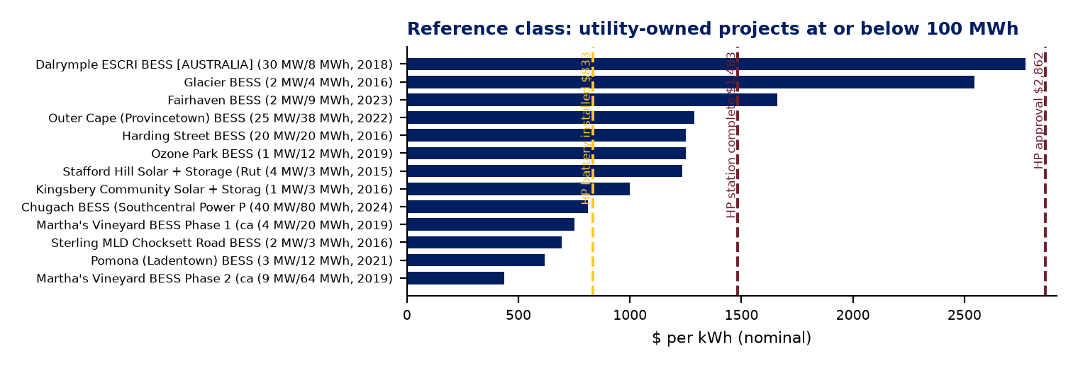

3.1 Dollar-year adjustment (added 2 October 2026)
The reference class above is in nominal dollars of the year each cost was reported, and nine of its thirteen members entered service between 2015 and 2019. A reviewer asked whether that understates the gap, given that battery prices were several times higher in 2018. The answer depends on which price is meant. BloombergNEF's pack survey is 1.6 times its 2018 level and 3.4 times its 2015 level; installed systems moved less (EIA's reported all-in for 2018 installs was $625 per kWh against LBNL's $458 for 2024, a factor of 1.4); and Lazard's Levelized Cost of Storage, which some reviewers cite, is roughly flat, down 24 percent from 2019 to 2025 and up 31 percent from 2020 to 2026 on the midpoint of its unsubsidized 100 MW, four-hour range. LCOS is in any case a $/MWh figure that bundles charging energy, operations, augmentation, financing and tax credits with capital cost, and is not a capital-cost deflator.
Each comparable was re-based to 2026 with a two-component model: the battery share of its cost (40 percent, with 30 and 50 percent as sensitivities) deflated along a battery index, and the remainder (station, civil, labor, interconnection, overheads) escalated at 3.5 percent a year as a proxy for an ENR-class construction index. Under the installed all-in index the median moves from $1,235 to $1,187 per kWh; under the pack index to $1,225; under BNEF's turnkey series (available from 2022 only) to $1,074; under the LCOS midpoint to $1,466; and with construction escalation alone to $1,480. Every member moves between 0.95 and 1.09 times its nominal value at the installed index. Hyde Park's station-complete direct cost ($1,483) stays at the 77th percentile under the first three indices and falls to the 54th under LCOS; the approval level ($2,862) stays at or above the top under all five. Deflating a comparable's whole cost at the battery rate, which is the arithmetic behind the challenge, gives a median of $575 and treats a 2019 project's switchgear, civil works and interconnection as if they were lithium cells. The formulas are on the workbook tab '2026$ Adjustment'.

3.2 New York distribution-scale cohort
A second review comment noted that New York has built many more projects of this size, most of them by NineDot Energy. NineDot reports eleven operating projects at six New York City sites (39 MW, September 2026) and closed $431 million of construction, tax-credit bridge and letter-of-credit financing in February 2026 for 28 further sites totaling 124 MW and 494 MWh. Three New York City Industrial Development Agency filings disclose all-in project costs: NineDot's Arthur Kill Road site (9.8 MW, 39.1 MWh, $43.4 million, $1,110 per kWh, $4,427 per kW), Elevate Renewables' Victory Boulevard site at an existing generation property (15.1 MW, 60.4 MWh, $31.65 million, $524 per kWh) and Soltage's Maspeth site (5 MW, $16.1 million, $805 per kWh on an assumed four-hour duration). NYSERDA's 6 GW Roadmap reports average total installed costs for its retail-tier (5 MW and below) projects of $464 per kWh for 2020-21 installations and $567 for 2022-23. These are developer-owned, four-hour, distribution-connected sites on leased lots with VDER revenue, a NYSERDA incentive and the investment tax credit; none carries a utility switching station, a landfill platform, a siting case, utility indirects or AFUDC, and none of the figures nets the incentives. On a dollar-per-kW basis NineDot's own filed budget is 77 percent of Hyde Park's approval level and 1.5 times its station-complete direct cost. The cohort also illustrates the interconnection point: NY-BEST and NYSEIA told the Public Service Commission on 11 March 2026 (Case 24-E-0621) that Con Edison's two-part interconnection test had raised upgrade costs about fourteen-fold on 34 distributed projects totaling 161 MW, an average of about $21 million per project. The cohort is shown on deck slide 13 and on the workbook tab; it was not added to the regression, which was not re-run.

4. Regression: size, duration and year
A log-log ordinary least squares model was fitted with heteroskedasticity-robust standard errors: ln($/kWh) on ln(MWh), ln(duration in hours) and calendar year. Results for the 26 projects: R-squared 0.65 (adjusted 0.60); size elasticity -0.17 (p = 0.012), so a tenfold increase in MWh lowers $/kWh by about 33 percent; duration elasticity -0.29 (p = 0.016), so doubling duration lowers $/kWh by about 18 percent, close to the 38 percent that Modo Energy's September 2026 survey reports for two-hour versus four-hour systems; and a year effect that is not distinguishable from zero (p = 0.68), which is what one expects when falling pack prices and rising installation, interconnection and tariff costs offset over the period. Adding ownership and Northeast dummies changes nothing of substance (R-squared 0.66, both p above 0.5), so the parsimonious model is used. The residual standard deviation of 0.36 in log terms means that a project of given size and duration lands within a factor of about 1.43 of the fitted value two times in three.
For a 20 MWh, two-hour project in 2028 the fitted value is $1,116/kWh and the 80 percent prediction interval is $611 to $2,037/kWh. Hyde Park's boundaries fall at the following percentiles of that predictive distribution: vendor contract 10%, installed battery 27%, station complete direct 73%, approval level 98%. The reading is direct. The battery is priced below what the population would predict for a project this small and this short. The station, complete and unloaded, is a high-normal outcome. The approval level is an outlier against public disclosures, and the memo's position is that the outlier is explained by scope that the disclosures do not carry rather than by pricing.
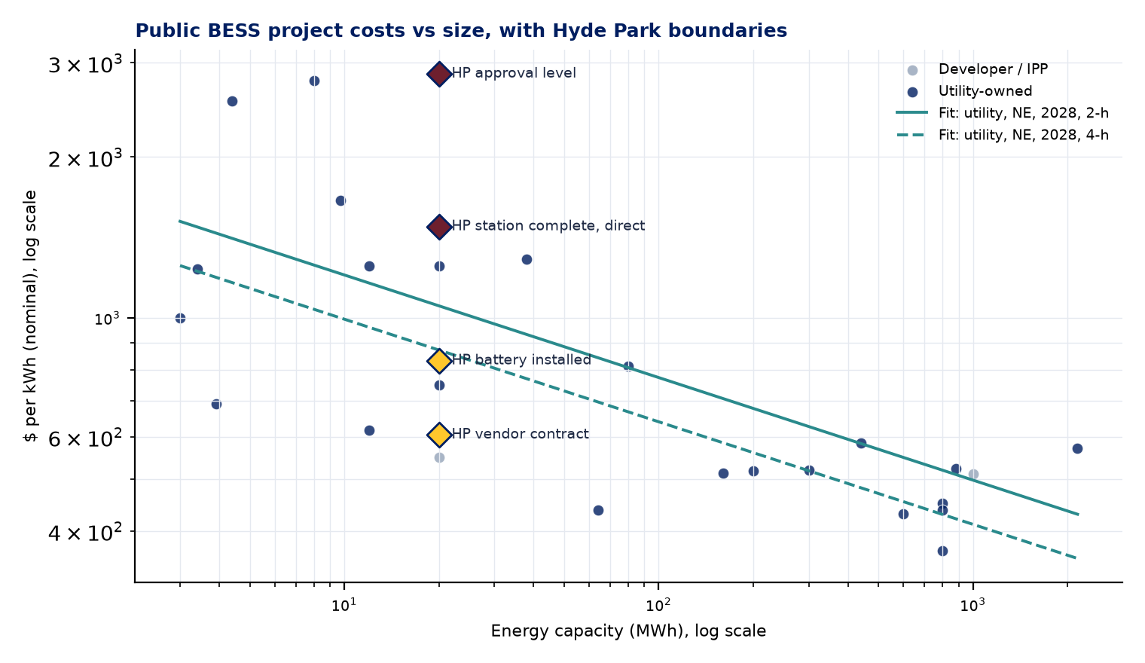

5. Monte Carlo on the estimate's own layers
The layered extraction makes a defensible simulation possible, because each layer has a known basis and a known maturity. A PERT distribution was assigned to each of the nine direct layers of Station 360, the Station 496 estimate was treated as a single layer, indirects were scaled with directs, and AFUDC was scaled with directs and with a schedule factor for up to twelve months of siting slip. The risk register and contingency were deliberately not added on top, because the layer ranges already model the outcomes the register is meant to fund; adding both would count the same exposure twice. Twenty thousand trials, fixed seed, no correlation between layers (a conservative simplification that narrows the tails; a positive correlation between the site, station and engineering layers would widen them). Two calibrations were run: base ranges from the specific evidence on each layer, and a wide calibration that stretches every upside by 60 percent to approximate an AACE Class 5 maturity.
Layer | Rev 3 direct | PERT low / mode / high | Basis for the range
A Battery contract | $12.99M | 1.00 / 1.02 / 1.08 of contract | Fixed price; change orders and LD exposure only. Escalation on the balance is a decision, not a risk.
B Battery installation | $1.73M | 0.80 / 1.00 / 1.90 | Labor basis is 25% of a 2023 site total; Rev 2 used 50%.
C GSUs, EMS, aux power | $1.93M | 0.85 / 1.00 / 1.35 | 2023 bidder list plus 3%/yr; GSU count 4 vs 12 on the 25 Aug one-line.
D Station 360 switching | $3.85M | 0.80 / 1.00 / 1.45 | Siemens budgetary +/-30% on breakers; balance from unit library at conceptual maturity.
E Landfill site platform | $2.69M | 0.60 / 1.00 / 2.60 | Haugland deducts ($1.47M confirmable) against geotechnical exposure ($0.6M / $1.6M / $3.5M) and soil ($0.4M to $2.6M).
F Station 496 protection | $7.25M | 0.80 / 1.00 / 1.40 | Own conceptual estimate incl. loaders.
G Testing and commissioning | $1.26M | 0.80 / 1.00 / 1.50 | Hours from E-23-373; 63-day commissioning window ownership open.
H Engineering, siting, PM | $4.42M | 0.90 / 1.00 / 1.60 | Engineering at 1.6% of total; EFSB fallback adds 18 to 24 months of legal and PM.
I Taxes, CWIP, BAR | $0.79M | 0.90 / 1.00 / 1.20 | Follows the base.
AFUDC schedule factor | $4.68M | 0.95 / 1.00 / 1.35 | Zero to twelve months of siting slip after the February 2028 determination.

Results. On base ranges the total is P10 $48.9M, P50 $51.3M, P80 $53.0M and P90 $54.0M, against a deterministic base of $49.7M without risk or contingency and an approval level of $57.2M with them. The reserve needed to reach P80 is $3.4M; the estimate carries $7.6M. On wide ranges the P80 is $55.9M and the P80 reserve is $6.2M, and the probability that the total exceeds the approval level is 10%. The uncertainty is concentrated in three layers: the landfill platform (standard deviation $0.93M base, $1.31M wide), Station 496 ($0.80M and $1.08M) and the owner soft costs ($0.51M and $0.74M). The battery contract contributes almost nothing to the spread. That is the statistical form of the whitepaper's argument: the money at risk is in the ground, the station and the process, not in the battery.
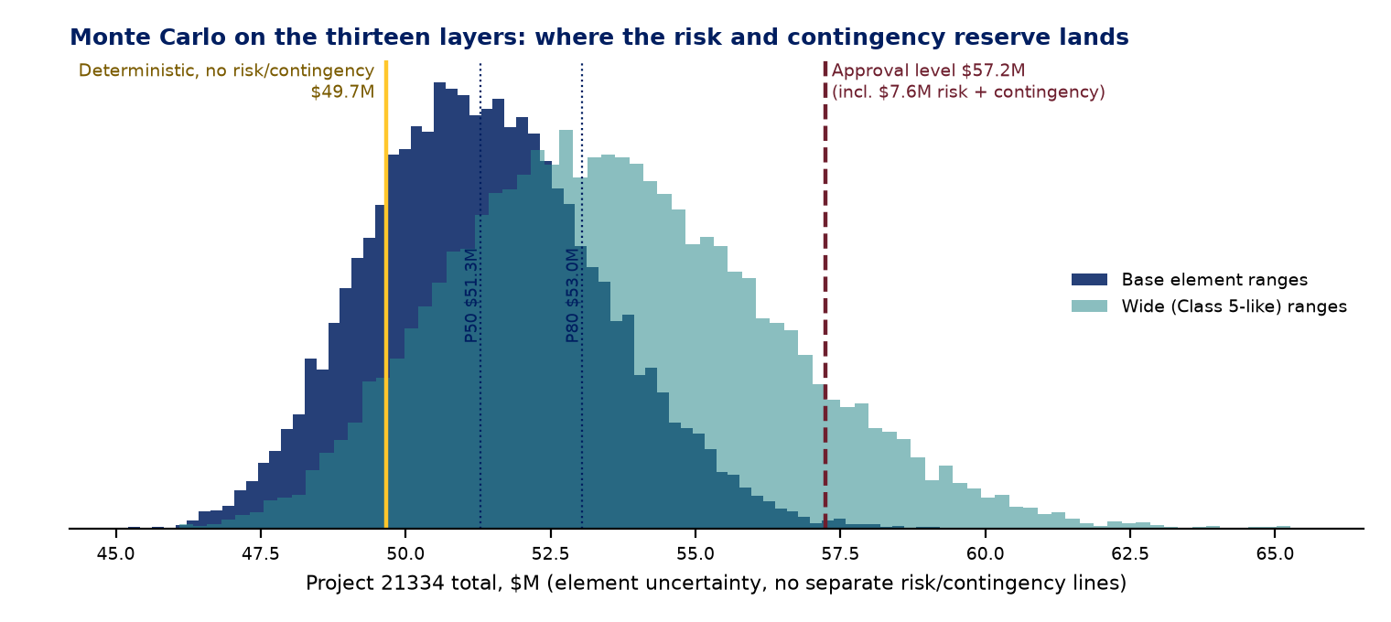
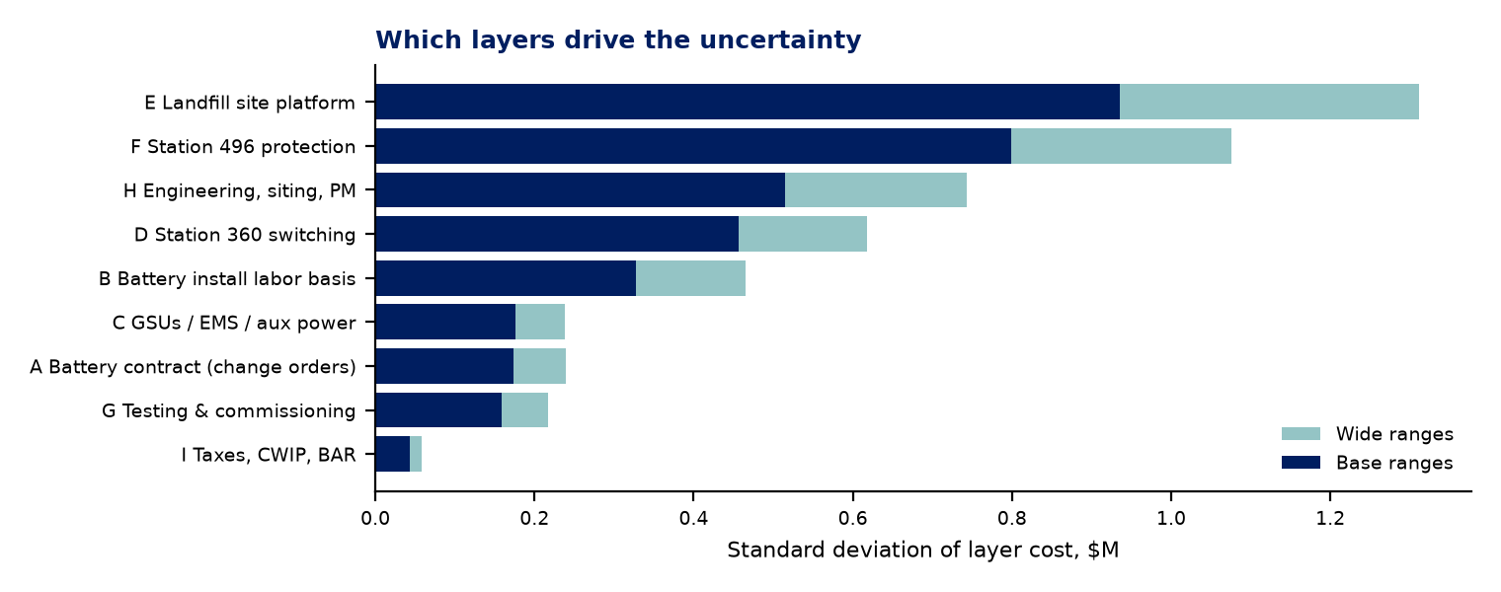

6. Estimate-to-actual uplift on comparable projects
A second, smaller reference class answers a different question: how far have conceptual or approved figures for small utility-owned batteries moved by completion? The dataset contains five observations. BGE Fairhaven went from $9.84M estimated to $16.16M actual (+64%). Eversource Provincetown was approved at $35M to $45M and closed at $49M (+9% to +40%). Hawaiian Electric Waena moved from about $60M estimated to an $82.1M approved cap (+37%) with a further increase requested for tariffs. SaskPower Regina rose from C$26M to C$34M (+31%). Hyde Park's own September cycle moved from $47.2M to $57.2M (+21%) as the battery line caught up to the contract. Five points do not make a distribution, but their median of about +31% is consistent with Flyvbjerg's finding that fewer than half of projects finish on budget and with Sovacool and Ryu's 2025 mean of +41% across 662 electricity projects, and it is well above the +1% to +13% that those authors report for solar, wind and transmission. Against that, the 17.9% risk-plus-contingency carried on Rev 3 is not generous. It is the reserve of a project that expects to hold its number, on a site and with an interconnection scope where the comparables did not.

7. Interconnection cost references from the ISO literature
Lawrence Berkeley National Laboratory's interconnection cost series gives the only systematic public data on what it costs to connect storage. In ISO New England, the storage median rose from $3/kW for studies in 2010 to 2017 to $148/kW for 2018 to 2021, with an all-status mean near $230/kW; network upgrades were 3 to 31 percent of completed projects' cost and 58 percent of active ones. The June 2026 interim results of ISO-NE's Transitional Cluster Study put average interconnection cost for 23 transmission-connected projects at about $664/kW, over $1,000/kW in western Massachusetts and about $177/kW in southeastern Massachusetts, and 21 of the 26 requests were batteries; one 500 MW / 2,000 MWh Section 83E winner withdrew citing those costs. NYISO is the only ISO where LBNL reports storage cost by size: $76/kW for 1 to 50 MW requests against $32/kW above 250 MW. Hyde Park is distribution-connected and avoids the ISO queue, but the point of comparison holds: its Station 360 and Station 496 layers, loaded, are $1,374/kW, which is the cost of building a dedicated switching station and reprotecting four feeders rather than tapping an existing bus. A transmission-connected 10 MW project in ISO-NE today would face interconnection costs of the same order before it built anything of its own.

8. How to use this in the argument
- Lead with the reference class, not the regression. Thirteen named projects with named costs are more persuasive to a non-statistician than a fitted line, and the placement of Hyde Park's direct cost among Fairhaven, Chateaugay and Provincetown is the single most useful fact this memo produces.
- Quote the regression as a bracket. 'Public disclosures imply $600 to $2,000 per kWh for a project of this size and duration; our direct cost is $1,483 and our approval level, which carries $23.7M of loaders that disclosures rarely include, is $2,862.' Do not quote a percentile to a regulator without the interval beside it.
- Use the Monte Carlo to defend the reserve, and rebuild it with the team. The distributions here are the analyst's reading of the evidence. Before full funding, run a two-hour range-estimating session (AACE 41R-08) with Substation Engineering, Civil, P&C, Siting and Haugland, replace each range with the room's, and add correlation between the site, station and engineering layers. The result will be a P50 and P80 that the project team owns.
- Verify the ten highest-priority public figures at source. Mass.gov utility-owned BESS page, the MD PSC pilot report, PGE's 2024 10-K, HEI's 10-Q, the CPUC SCE resolution, the NYPA and O&R releases, and the LBNL ISO-NE brief. Until then every external use of these numbers carries the retrieval caveat.
- Keep the layered view as the frame. Every statistical result above is only interpretable because the estimate was first separated into layers with definitions that match the benchmarks. The statistics bolster the argument; the extraction is the argument.

Appendix. Sources and methods
- Dataset: bess_projects.csv (44 rows) and bess_projects_notes.md, compiled 29 Sep 2026 from regulator orders, utility releases, 10-K filings and trade press; per-project quotes and known data problems in the notes file.
- ISO, FERC and state references: iso_ferc_refs.md, 29 Sep 2026 (LBNL interconnection series for ISO-NE, PJM, MISO, NYISO, SPP; ISO-NE Transitional Cluster Study interim results, June 2026; FERC Order 898 storage accounts; MA DPU 17-05 and 17-13; NY PSC 18-E-0130 and NYSERDA State of Storage 2025; CPUC, HI PUC, CT PURA and NJ BPU program data).
- Methods: AACE International RPs 17R-97 and 96R-18 (classification), 40R-08 (contingency principles), 41R-08 (range estimating), 42R-08 (parametric), 57R-09 (Monte Carlo), 66R-11 (distribution selection), PGD-02 (quantitative risk analysis guide); Flyvbjerg and Gardner, How Big Things Get Done (2023); Sovacool and Ryu (2025), Energy Research and Social Science.
- Model code: stats_model.py (statsmodels 0.15 OLS, HC1 errors; prediction intervals at 80%) and mc_model.py (numpy, 20,000 trials, seed 21334, PERT via beta with lambda 4). Both in the build folder with the results JSON files.

